Athlete Guide

Give it a Tri
June 18th, 2023
Echo Lake Provincial Park

Sponsored by

Schedule of Events - Give it a Tri

Saturday June 17th
12:00-3:00 Package pickup at Dutch Cycle – 1336 Lorne st, Regina, Sask

Sunday June 18th
6:30 Transition opens
6:30-7:30 Registration and body marking, under Regina Multisport Tent
7:15-7:45 Swim area open for warm up
7:30 MANDATORY Athlete Meeting at Beach Front & Swim Angels assignments
7:50 Transition CLOSES
8:00 Sprint Athletes START
8:20 Try-a-Tri Athletes meet on Beach. Please note, prior to this, we will have an area in the water that you can warm up in.
8:30 Try-a-Tri Athletes START

Please note, everything will take place in the grassed area by the beach including the lunch and prize giveaways from our sponsors. If the weather is ugly we will move the lunch to under the new covered gazebo at the park.
The lunch will start at approximately 10:45 but it will depend on when the last
racer comes in, we will aim to start about 15 mins after that. Once the last runner
heads out on the course, we will open transition up to finishers so they can start cleaning up their stuff. The sooner we can clear out transition the better.

Package Pick-up
This will be at Dutch Cycle, 1336 Lorne St. from 12:00-3:00 on Saturday. If you are
unable to make it on Saturday, please try and make arrangements for someone else to get it for you. If you’re really stuck, let me know and email krysruzicka@outlook.com and we can TRY and make arrangements for you.

Timing
We will have chip timing. You will pick this up Sunday morning at the race site.

Showers
There aren’t any showers right at the race site so you may want to bring dry clothes at the very least. There are showers available at the campgrounds in Echo
and Pasqua but you will have to pay for a day pass for the park which is $7.

The Course (the Course map is on the last page)

Swim
The swim is a two-lap course, each lap 375m. For any of you that are nervous
about the open-water swim, this course is great for you. The water is shallow throughout and you can touch the bottom for part of it. If you ever feel nervous
you can swim about 10m to get to the shallow part. We will also have kayaks, paddleboarders and a motorboat in the water. If you need a break or just need to relax, you can hold onto a kayak for as long as you need. You just can’t make any forward progress. The person in the kayak will allow you to keep swimming when he/she feels that you are comfortable to carry on.

It is a triangular course utilizing the swim buoys set up for the park use. We are swimming clock-wise. From the main beach, the first big, yellow buoy will be on
your left when looking out. Swim towards it and around it (keeping it on your right) and follow the white buoys to the next big yellow buoy, go around that (keeping it on your right) and head back to the yellow buoy on the beach. You will need to get out of the water (listen to all the cheers from the crowd) and then head back into the water for the second loop and repeat what you just did.

Once you complete your second loop you will have a short run to the transition
area where you’ll get ready to bike. It is approximately 75 m to the first buoy,
225m to the second buoy and 75 m back to the beach.
**For the Super Sprint, the swim is only one lap of the 375m course.

Swim Angels
Swim Angels are people that will swim beside you guiding you through the swim – if you are a nervous swimmer. You can request one when you register. If you
requested one, we will pair you up with one at the race, 7:30 on the beach, after
the race meeting.
**Wetsuits are allowed if the water temperature is under 24 degrees Celsius

Transition
The transition area is on the grassed area close to the beach. There is only one transition so you will return here after the swim and bike. We will have enough bike racks so you can spread your bikes out well but please keep in mind you don’t have a lot of room for all your stuff. Please keep your area tidy. We understand you’re trying to transition as quickly as you can but please keep all your things together to prevent others from tripping over them or from losing some of your
stuff.
**PLEASE NOTE: It is a Triathlon Canada rule that you must have your helmet on
AND FASTENED before you can take your bike off the rack. The Saskatchewan Triathlon officials will be watching closely for this. Also, when you return after the bike, you can’t UNFASTEN your helmet until your bike is racked.

Bike
Once you have all your bike gear on - including your helmet with your chin strap
fastened, unrack your bike and exit transition. Please note, you are not allowed to get on your bike until after the MOUNT line. You must walk with your bike until then.
After exiting transition, follow the pylons to the parking lot and continue walking with your bike to the MOUNT line. We will have this marked with pylons as well as
a volunteer there. After crossing the mount line, you will get on your bike. Please
be aware that we have to allow room for cars to come into the park so the chute leading you to the road is narrow and you’ll have to go single file. Please be courteous to the other racers – you will get to the road in due time. It is only about 150m or so.
You will head out on Hwy 56 and take your first right towards Fort Qu’appelle.
Follow that road for approximately 9.5k and as you near the town, it turns into
3rd Street. You will follow straight down this road that veers left and turns into Hudson place. You will then approach a Stop sign at Broadway Ave but there will be barricades and volunteers directing traffic so you won’t have to stop. Carry on through town, keeping right, then Broadway Ave. turns into Hwy 210. Follow that around the lake until you get back to Hwy 56. Turn right at the stop sign, and you will soon be back at the lake.
There will be volunteers directing you to slow down and DISMOUNT before the line. After dismounting your bike, walk with it back to transition and rack it. After racking your bike you are free to remove your helmet and other biking gear to get ready to run.
Please note, the bike course isn’t closed to traffic so please be aware of cars and
follow all road rules. Also, there has been some concern with dogs in the first 3k or so of the bike. We are aware of this and we have a plan in place so you don’t
encounter any dogs during the race. IF you do, please proceed with caution.
You must always stay to the right and are only allowed to pass on the left. If you
are passing someone, please yell out ‘on your left’ so they know you are passing.
You will be penalized if you pass on the right.
**The bike course is the same for the Sprint and Super Sprint.

Bike Support
We will have Dutch Cycle doing bike support for the day. They will be there before the race to help with any last-minute things you need for your bike and they will also be out on the bike course. If you get a flat tire, they will help you change it (or give you a replacement wheel) to help you get you on your way. It is still recommended that you carry a flat repair kit with a spare tube in case Dutch Cycle can’t get to you right away.

Drafting
Drafting is riding close behind someone which helps block the wind and allows the
person behind to use less energy. Drafting is allowed in draft legal triathlon events but NOT in this race. You can be penalized if you are too close to the person in
front of you. You must allow 10 m (4-5 bike lengths) between you and the person in front of you. You are allowed to be closer if you are passing someone in front of
you, and you have 20 seconds to complete your pass. If you get passed by
someone else, it is your responsibility to drop back to allow 10 m between. There
will be race officials on course watching for drafting. They will give you a warning if
you are riding too close to the person in front of you. This is for safety reasons, so
please keep this in mind while on the bike section of your race.

Run
Once you’ve completed the bike you will head back to transition and rack your
bike. Again, remember you need to rack your bike before you unfasten your
helmet. Change into your running gear and head out. You will be required to wear a race number (bib) on the front of your running shirt. It must be fastened by pins or the best option is a race belt.
The run is an out and back (two loops for Sprint athletes). Please note, we’ll
have markings on the road and lots of volunteers to guide you. You will run out on
the path behind transition (along the beach) and along a grassy area. You
will cross over Hwy 56 and turn left and run on the road until you get to the Pasqua Lake gate. Turn right towards Pasqua Lake. Take your first right into the parking lot towards the mini golf and then do a turnaround to the end of the parking lot. You will then turn right until you hit your first left, towards to the Hole in the Wall campground. This corner is where the water station will be. You will run to the end of the parking lot and turnaround (there is also washrooms in here if need be). You will run back through the parking lot veering right and following the road that goes up a slight hill and around the bathrooms. Turn right as if you were heading back, but before you turn back, at the next intersection (where the water station is), you will turn right and head toward Group 1 camping for a small but challenging uphill loop. There will be someone there at the point where you turn around.
You will head back down-hill and straight past the water station. You will turn right at the intersection where the trees end. Continue to the highway, turn left on the
highway and run on the same side of the road you came out on. Try-a-Tri athletes will run past the highway turnaround and cross the highway, go back on the grassy path and run to the finish line.
**Sprinters will do TWO loops of the run course for the 5km run. The turnaround for the second loop will be on the highway road**
Take in all the cheers and smile for the camera! You’ve just done something really awesome!!! You gave it a tri and just became a TRIATHLETE!!!

Run course map below

Post Race – Finish, Lunch and PRIZES
After you cross the finish line, there will be some light snacks, water and Gatorade.
The lunch and awards will start at around 10:30 am or as soon after the last
finisher. We will open up transition when the last runner heads out so you can start.
packing up your gear. The sooner we can clean up the better.
If you’re able to stick around after the race to help tear down and clean-up, we’d
really appreciate it. If everyone pitches in a bit, it goes by fast.

Thanks for taking part in the race. If you have any questions or concerns, please contact the Race Director, Krystle Ruzicka. Krysruzicka@outlook.com 306-535-0796. Please keep this number for any issues leading up to the race or race day emergencies.

Please see below for current Sask Triathlon rules.

Saskatchewan Triathlon Association Corporation (STAC)

2018 Triathlon Rules Summary for Spoke n’ Hot Women’s Triathlon

On behalf of STAC officials, here is a summary of key triathlon race rules to make sure your participation in the triathlon is safe and fun. The full set of International Triathlon Union (ITU) rules is at:
www.triathlon.org/about/downloads/category/rules.

Transition set-up
-Prior to race day, please remove all bike ‘accessories’ that will create safety concerns; such as mirrors, climbing bars on mountain bikes, and loose equipment. Pedal toe clips are allowed, but the straps must be removed.
-Make sure handlebar ends are plugged, not open
-Hang your bike on the bike rack bar by its seat
-Bring a proper cycling helmet (not one from any other sport) that is free of cracks; the chin strap needs to be tightened so only two fingers can be inserted together horizontally
-Your helmet must be on at all times when you are in contact with or riding your bike – even during warm-up
-Refrain from biking in the transition area
-Athletes only in the transition area. Keep equipment to a minimum to ensure the transition area is not cluttered; only have what’s needed for your race, and keep backpacks out of transition

Swim
-Wear the supplied swim cap
-Forward progress is only by swimming – refrain from walking on the swim bottom
-There is no changing out of swim suits after the swim
-The swim start will be from shore
-A final decision on allowing wet suits will be announced an hour before race start based on water and air temperature readings
-If you are a weaker swimmer, let the stronger swimmers go in front
-You can rest by holding onto a kayak or boat. If you are wanting to continue, do not climb on
-Swim around all turning buoys. Buoys in the water between the turning buoys are for help in sighting and can be passed on either side

T1: Transition to Bike
-Put your helmet on before touching your bike
-Walk or run your bike past the mount line
-When mounting your bike, watch for other athletes already on the course

Bike
-If your bike has disk brakes, it will be allowed to enter this event
-Keep your distance from other cyclists – a bit more than 10 meters from the cyclist in front of you
-If you are ready to pass, call out “passing on your left” and pass within about 20 seconds
-If you are being passed, don’t speed up; wait for the other athlete to come alongside then pull
back within about 5 seconds until you are the 10 meters back from the cyclist that passed you
-Watch for obstacles on course (like pedestrians). At intersections that are not controlled by
volunteers on a closed course, you must obey the traffic signs and signals

T2: Transition from Bike
-Get off your bike before the dismount line
-Walk or run your bike back to the same spot on the bike rack
-Rack your bike, then remove your helmet
Run
-Go fast!

Other reminders…
-Refrain from leaving anything on the course (garbage or gear)
-Entertainment electronics, iPhones or headphones are strictly prohibited and cannot be used
during the race
-Your entire torso must be covered on the bike and run
-If you decide to not finish the race, notify an official and hand over your timing chip
-Thank the volunteers!
-Have a great race!

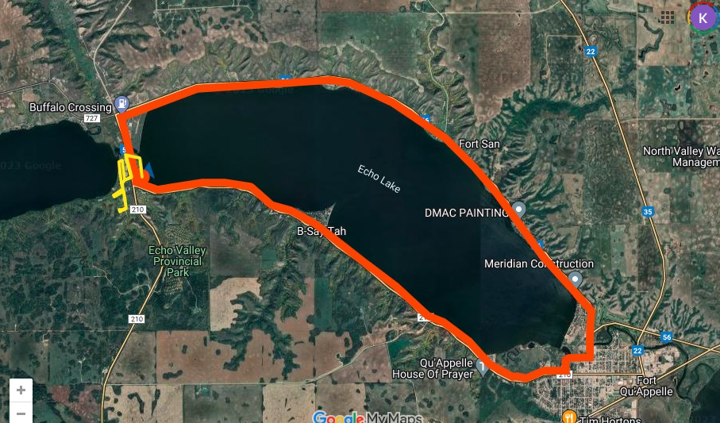
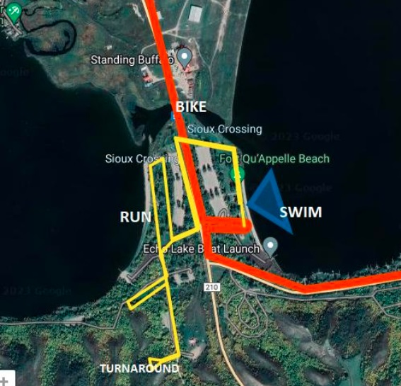

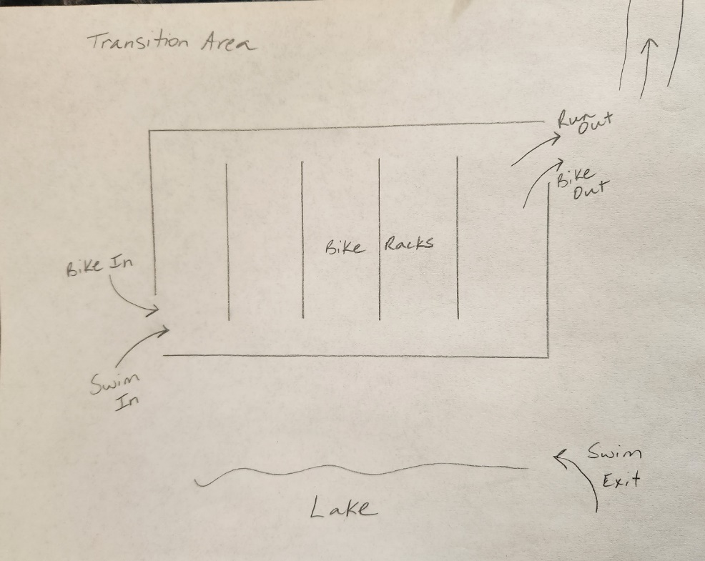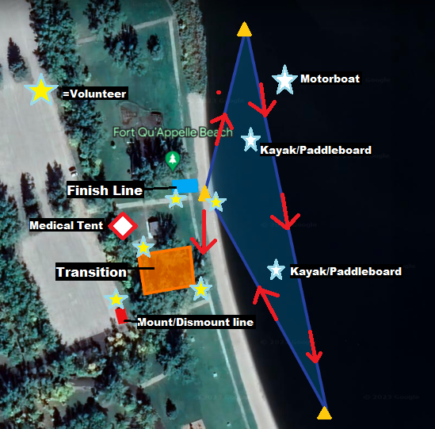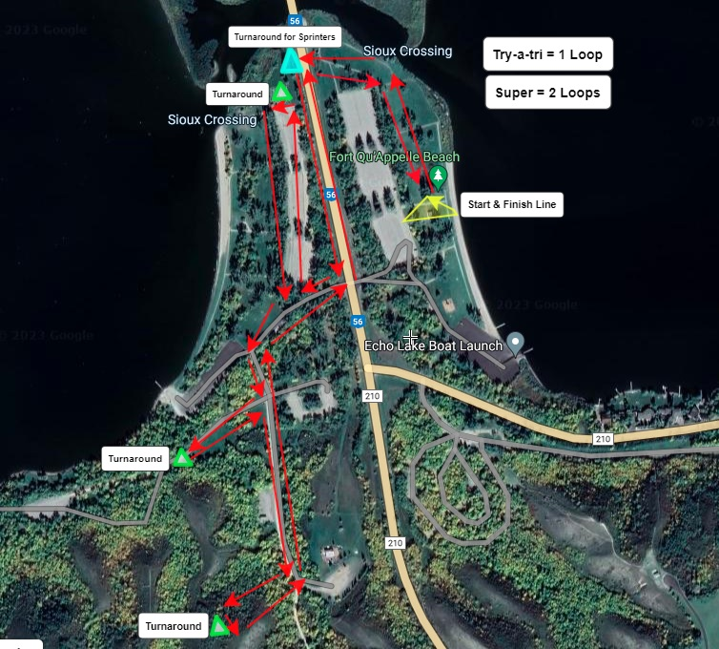

Thank you to our sponsors for your support and donations!

