**Athletes’ Guide**

**Western Cycle Echo Lake Multisport Festival**

**July 5 & 6, 2025**

Disclaimer: The Athlete Information Guide is as accurate as we can make at the time of distribution; it will continuously be updated to reflect the current venue and course conditions. Please check our website for any changes made to the race day.

[reginamultisport.com](https://www.reginamultisport.com/)

**Thank you to our sponsors!**



**Welcome Back to Racing**

On behalf of the entire **Regina Multisport Club** Board, it is my great pleasure to welcome all athletes back to the Echo Lake Multisport Festival. We truly appreciate your patience and support as our team has worked hard behind the scenes to create an unforgettable event.

Whether you're a seasoned triathlete or tackling your very first race, we are thrilled to have you with us. As you prepare to test your limits, we want to acknowledge your dedication, perseverance, and passion for the sport. The path to this moment has likely been filled with early mornings, tough workouts, and personal sacrifice — and we commend you for your unwavering commitment.

We also recognize and give thanks that we live, work, and play on the unceded lands of Treaty 4 Territory and the Homeland of the Métis. It is a privilege to host our event on this land, and we honor its deep history and traditions.

On race day, please take a moment to thank the incredible volunteers who help make this event possible. Their tireless efforts ensure that your race experience is safe, supportive, and enjoyable. Again, this year, our goal is to offer two race days to foster a stronger sense of community—giving participants the opportunity to race one day and volunteer the other. Saturday features the Kids of Steel and National Development Series events, while Sunday starts with National Development Series event, followed by Age Group events with Team Canada World Championship Qualifying Spots available. If you haven’t already, please visit our volunteer page and consider giving back to your fellow athletes. [volunteers@reginamultisport.com](mailto:volunteers@reginamultisport.com)

From all of us at the **Regina Multisport Club**, we wish you the very best of luck on race day. May you find strength in your training, joy in the journey, and fulfillment as you cross that finish line. I look forward to welcoming you there!

**Happy Triathloning,**

**Jennifer Masur**

**President, Regina Multisport and Race Director, Western Cycle Echo Lake Multisport Festival**



**Race Event Schedule**

Athletes’ Briefing will be held on **Wednesday July 2nd**by **Zoom.**

* **6:00 pm to 6:45 pm SK time for Dev Series Athletes**
* **6:45 pm to 7:30 pm SK time for Age Group Athletes**

**Join Zoom Meeting**  
<https://us02web.zoom.us/j/85191163028>

It will be recorded and uploaded to the club website for those that cannot attend. Please find the link to the meeting: Zoom

**Age Group Athlete race package pickup** will be at Western Cycle Source for Sports, 1550 8th Ave, Regina from **4-7 pm on Thursday July 3**.

**Dev Series package pick-up 3-4 pm on Friday, July 4th, at Echo Lake Provincial Park down by the beach**. NOTE: The racer must show a government-issued photo ID for package pickup. If you are coming from out of town and unable to make the pickup, please contact president@reginamultisport.com to arrange an alternative pickup.

|  |  |  |  |
| --- | --- | --- | --- |
| **Wednesday July 2** | | | |
| 18:00 | 18:45 | Dev Series Briefing (Online – will record) | Zoom |
| 18:45 | 19:30 | Age Group Briefing (Online - will Record) | Zoom |
|  |  | **Thursday July 3** |  |
| 16:00 | 19:00 | Age Group Package Pick up | Western Cycle |
| **Friday July 4** | | | |
| 14:00 | 15:00 | Swim Course Familiarization | Echo Lake Beach |
| 15:00 | 16:00 | Dev Series Package Pick up | Echo Lake Beach |
| **Saturday July 5** | | | |
| 6:30 |  | Dev Series Check-in, Transition open | Echo Lake Beach |
| 6:30 |  | Wetsuit Announcement | Echo Lake Beach |
| 6:45 | 7:00 | Swim Warmup | Echo Lake Beach |
| 7:00 | 7:15 | Dev Series Pre-Race Athlete Briefing​ | Echo Lake Beach |
| 7:30 |  | Dev Series 2X Aquathlon Relay | Echo Lake Beach |
| 8:00 |  | Kids of Steel (KOS) Check-in/Wrist band assignment | Echo Lake Beach |
| 8:15 | 8:30 | KOS Swim Warmup | Echo Lake Beach |
| 8:30 |  | **14-15 (**375m swim/1.5 km run)​ -Red | Echo Lake Beach |
| 8:45 |  | **12-13** (375m swim /1 km run)​ - Blue | Echo Lake Beach |
| 9:00 |  | **10-11 (**200 m swim/500 m run)​ -Orange | Echo Lake Beach |
| 9:15 |  | **8-9** (100 m swim / 400 m run) - Purple | Echo Lake Beach |
| 9:30 |  | **6-7** (50 m swim/200 m run) - Yellow | Echo Lake Beach |
| 9:45 |  | **4-5** (25 m swim/100 m run) - Black | Echo Lake Beach |

| **Sunday July 7** | | |  |
| --- | --- | --- | --- |
| 6:30 | 7:45 | Transition Open/Body Marking Dev Series | Echo Lake Beach |
| 6:40 |  | Wetsuit Announcement | Echo Lake Beach |
| 7:30 | 8:30 | Transition Open/Body Marking Standard Triathlon, Standard Aquabike | Echo Lake Beach |
| 8:00 | 9:00 | Transition Open/Body Marking Sprint Triathlon, Sprint Duathlon, Sprint Aquathlon | Echo Lake Beach |
| 7:00 | 7:20 | Dev Series Swim warmup​ | Echo Lake Beach |
| 7:30 | 7:35 | Mandatory Dev Series 12-15 Athlete Briefing​ | Echo Lake Beach |
| 7:40 |  | Dev Series 12-15 Male Super Sprint Draft Legal Start​ | Echo Lake Beach |
| 7:45 |  | Dev Series 12-15 Female Super Sprint Draft Legal Start | Echo Lake Beach |
| 7:50 | 7:55 | Mandatory Dev Series 16-19, U23 Athlete Briefing | Echo Lake Beach |
| 8:00 |  | Dev Series 16-19, U23 Male Sprint Draft Legal Start | Echo Lake Beach |
| 8:20 |  | Dev Series 16-19, U23 Female Sprint Draft Legal Start | Echo Lake Beach |
| 8:10 | 8:30 | Age Group Athlete Swim Warm Up | Echo Lake Beach |
| 8:30 | 8:40 | Mandatory Standard Triathlon, Standard Aquabike Athlete Briefing | Echo Lake Beach |
| 8:45 |  | Standard Triathlon & Standard Aquabike Start | Echo Lake Beach |
| 9:10 | 9:20 | Mandatory Sprint Triathlon & Sprint Duathlon & Sprint Aquathlon Athlete Briefing | Echo Lake Beach |
| 9:30 |  | Sprint Triathlon and Sprint Aquathlon Start | Echo Lake Beach |
| 9:35 |  | Sprint Duathlon Start | Echo Lake Beach |
|  |  |  |  |
| 11:30 |  | ​Awards Ceremony​ | Echo Lake Beach |
| 11:00 | 12:30 | Pancake breakfast | Echo Lake Beach |

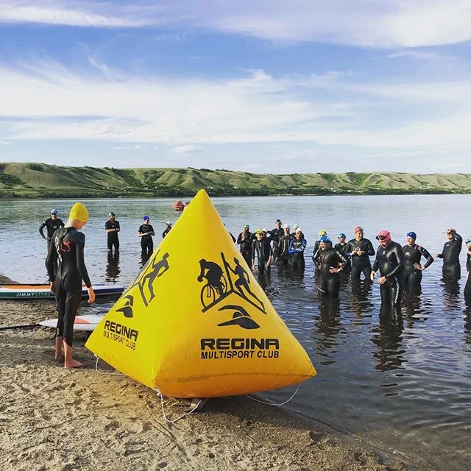

**Swim**

**SWIM CAP**

The swim cap placed in your race packet must be worn during the swim. Do not trade your swim cap with another athlete, as the caps are color-coded to assist race management in organizing you at the swim start. If you choose to wear a secondary cap, it MUST be worn under your official race cap.

Swim Cap Colors:

**Super Sprint Distance - White**

**Sprint Distance - Blue**

**Standard Distance - Green**

**WETSUITS**

The wetsuit decision (mandatory, allowed, or forbidden) will be announced on race morning by a Tri Sask Official one hour before race starts.

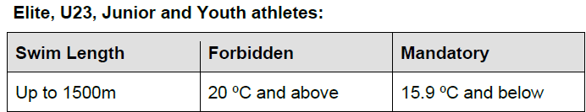

**NOTE:** We know that as an athlete you are concerned about the lake temperature for race day, but we will not respond to emails regarding wetsuit temperature. Athletes should be prepared for all possible scenarios.

The swimming course will be monitored by boats, kayaks, and paddle boarders who each cover a particular section of the course. Medical personnel will be standing by at the swim start/finish area for the duration of the swim should anyone require medical assistance.

**Swim Course Cut off:**

Standard: 1 hour 10 mins after the final Standard athlete enters the water. Sprint: 30 minutes after the final Sprint athlete enters the water. NOTE: Athletes exiting out of the water after cut-off will not be allowed to continue.

**Swim Course Map:**

Open water (lake) swim moving clockwise around the swim buoys. The start and finish areas of the swim are the main beach. Swim Course distances as shown on the following map.

**Sprint - Large Loop = 750 m**

**Standard – Large Loop X 2 = 1,500 m**

**Super Sprint – Small Triangle = 375 m**

**Transition**

Transition is located on Echo Lake beach, approximately 25m from Swim Start/ Finish Line area. ***Transition Opens at 6:30 am on race morning for Dev Series and 7:30am & 8:00am for Age Group athletes***. A bike mechanic from Western Cycle will be available.

**Transition Area Conduct**

Have your chip on and number marked on body with number on bike and helmet before entering to set up transition.

For safety reasons, you will not be permitted to ride your bike in or out of the transition area. There will be mount and dismount lines marked on the parking lot area, as well as by a volunteer.

Please remove any bags or other equipment not needed for the race and place them back in your vehicle or place them on the perimeter fencing inside the transition area. Any bags, bins, or other items placed beside your bike that exceed the allowable space will be moved to the perimeter of the transition area during the first leg of the race once the transition has closed.

Any markings used to make sighting your bike easier (balloons, towels, markings on the ground) will be removed during the first leg of the race.

Please remove all your personal items at the end of your race day and deposit any garbage in the bins provided before leaving the transition area.

In T1 (before the swim) rack your bike by its seat with your transition race stuff (and only race stuff) on one side or the other of the front wheel, and no further out than the front wheel.

When touching your bike in transition (T1), you must have your helmet on and clipped up.

For T2 (returning from bike), rack your bike back in your same spot with front wheel pointing in or out, and by the seat or by both brake levers. Do not unclip or remove your helmet until your bike has been properly racked.

**Bike**

The course features a transition from rolling to flat terrain, situated in the legendary Qu’Appelle Valley, with a few rolling hills around the beautiful Echo Lake. Participants will leave the Echo Beach area, head north around the lake, and pass through the town of Fort Qu’Appelle before heading south on B Say Tah Road to the park entrance and transition area. One loop is approximately 20km - Sprint will do one loop of this course, and Standard will do two loops.

The course is located on the east side of Highway 210, and the roads will remain open to traffic. Athletes need to be aware of their surroundings and follow the instructions of traffic control personnel.

Standard AQUABIKE athletes will complete the same bike course as Standard athletes.

Sprint DUATHLON athletes will complete the same bike course as Sprint.

Dev Series Super Sprint athletes will complete an out-and-back course on Highway 56, with the turnaround point located 3 kilometers from the transition. The total distance covered will be 6 kilometers.

**Bike Drafting**

For the age group non-drafting races, the draft zone is 12 meters from your front bike wheel to the front bike wheel of the athlete in front of you.

You must pass within 25 seconds of entering the draft zone.

Blocking another athlete from passing you is also prohibited. The penalty for drafting is 1 minute for standard distance and 30 seconds for sprint, to be served in T2.

For the safety of all participants, headphones and earbuds are not permitted during either the bike or run portions of the event.

Athletes are to carry hydration on the bike course.

**Penalty:** If you are given a penalty on the bike course, you must stop in transition (T2), find and notify a Technical Official in transition, and then serve your penalty time.

Bike Course Cut Off Time: 3:10 hours after Standard swim start (approximately 12:10)

**Dev Series 12-15 Super Sprint= 6 km (Thunderbird Lodge Turn around)**

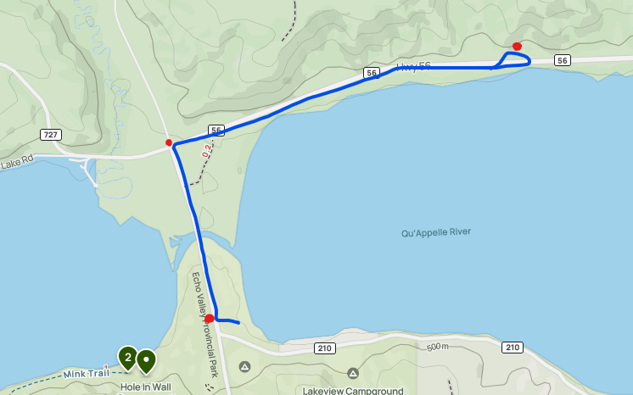

**Sprint and Standard = 19.04 km**

**Run**

**RUN COURSE:**

**Super Sprint Distance= the Run Course:**

* Run out of transition (where you exited for your bike) and take a slight right along a grassy area and towards a concrete path.
* Follow concrete path which will transition to a grassy path along the lake, towards the highway.
* Complete 1.5 k = 2 loops within grassy area

**Sprint Distance= 1.5 Loops of the Run Course:**

* Run out of transition (where you exited for your bike) and take a slight right along a grassy area and towards a concrete path.
* Follow concrete path which will transition to a grassy path along the lake, towards the highway.
* Cross over Hwy 56 and run on the road until you get to the Pasqua Lake gate and turn right, and slight left towards aid station
* Turn right at first aid station and continue to the Hole in the Wall Campground entrance
* **Starting First Loop:**
  + Run on the right side of the road to the end of the parking lot
  + **Turn around** at pylon/volunteer
  + Staying on right, run towards the hidden campground, with washrooms left
  + Turn right and continue back towards the water station
  + Turn right at the water stations head towards Hidden Coulee Campground
  + **Turn around** at the end of Hidden Coulee Campground back to the water station
* **Half loop** is completing the Hole in the Wall Campground section again.
  + There will be volunteers, markings, and signs to help you along the way.
* **Return to Finish:**
  + At the water stations turn left to exit the campground
  + Turn right at bottom of hill towards the highway.
  + Turn left on the highway and head towards the cross over on Hwy 56
  + Turn right crossing over Hwy 56 towards the grassy area
  + Follow grassy path to Finish line

**Standard Distance = 4 Loops**

* Run out of transition (where you exited for your bike) and take a slight right along a grassy area and towards a concrete path.
* Follow concrete path which will transition to a grassy path along the lake towards the highway.
* Cross over Hwy 56 and turn left and run on the road until you get to the Pasqua Lake gate, and left towards aid station
* Turn right at first aid station and continue to the Hole in the Wall Campground entrance
* **Starting First Loop:**
  + Run on the right side of road to the end of the parking lot
  + **Turn around** at pylon/volunteer
  + Staying on right, run towards hidden campground, with washrooms to left
  + Continue back towards the water stations
  + Turn right at the water station, head towards Hidden Coulee Campground, t**urn around** at the end of Hidden Coulee Campground back to the water station
* **Repeat first loop 3X:**
  + Turn left into Hole in wall campground
  + Run on the right side of road to the end of the parking lot
  + **Turn around** at pylon/volunteer
  + Staying on right, run towards hidden campground, with washrooms to left
  + Continue towards the water station
  + Turn right at the water stations head towards Hidden Coulee Campground
  + **Turn around** at the end of Hidden Coulee Campground back to the water station
* **After Fourth Loop:**
  + At water stations proceed downhill to exit campground
  + Turn right at bottom of hill towards the highway.
  + Turn left on the highway and head towards the crossover on Hwy 56
  + Turn right crossing over Hwy 56 towards the grassy area
  + Follow grassy path to Finish line

**Run Course Cut Off: 1:30 pm**

**AID STATIONS:** You will pass Aid Stations multiple times on the Run Course, serving water. Aid stations are marked on the Run Course map for reference.

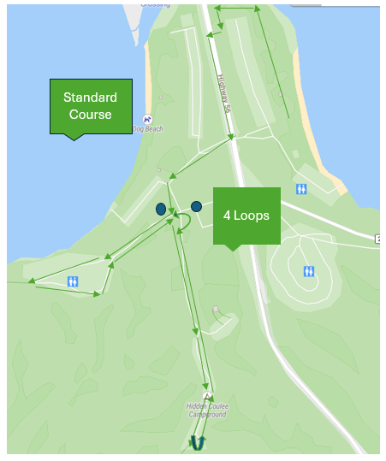

**Aquabike/Duathlon/Aquathlon**

The Aquabike will follow the same swim and bike course as the Standard. The Aquabike official overall time for ranking will be recorded at the entrance of transition (T2) when you finish the bike course. Athletes can then take their time racking their bike, changing shoes, and making their way to the finish line area to be called across the line and collect their finishers’ medal.

* Standard Aquabike - 1500m swim, 40km bike
* Sprint Aquathlon - 750m swim, 5km run

Duathlon will follow the same run 1 and bike course as the Sprint. The run 2 course will be half the run 1 distance. The duathlon will start at the exit from transition.

* Sprint Duathlon - 5km run, 20km bike, 2.5km run
* **Sprint Duathlon = 2.5 Run (last leg)**

Aquathlon will follow the same swim and run course as Sprint.

**Kids of Steel (KOS) and Wrist band assignments**

Age 14-15 - 375m swim/1.5 km run -Red

Age 12-13 - 375m swim /1 km run – Blue

Age 10-11 - 200 m swim/500 m run -Orange

Age 8-9 - 100 m swim / 400 m run – Purple

Age 6-7 - 50 m swim/200 m run – Yellow

Age 4-5 - 25 m swim/100 m run - Black

The swim will be along the beach shore (no deeper than standing depth) with multiple loops depending on age/distance.

The run will take place in the grassy area on Echo Lakeside only, multiple loops depending on the age/distance.

1.5 km is the same loop as the super sprint course.

**Timing & Results**

Unofficial results will be posted on Zone4.ca web site, in real time.

DROPPING OUT: Please notify a race official and return your timing chip at the finish line if you drop out of the race. Please do not cross the timing mat at the finish.

**Parking**

**Where to park on race day?**

Parking will be available in the Parking lot, South of the race site. (Fishing Parking Lot)

**Please do not park in lots on the north side of the highway, as these are part of the course.**

**Race Items**

**Wristband**

A wrist band will be affixed to your wrist that will match in same color as your swim cap. This band will help officials and volunteers identify the event athletes are participating in.

**Timing Chips**

Timing chips will be provided by Zone 4 at the Echo Lake athlete check-in from 6:30 to 9:00 am. Body marking will be completed during this time. On Sunday, your left arm and left leg will match your bib number.

**Where Does the Timing Chip Go?**

The chip should be affixed by your left ankle prior to swim start and must be worn during the entire event. If you lose your timing chip, please go see the timers. There will be a charge for lost chips, and they will be invoiced from our timing company.

**Washrooms/Toilets**

Park bathrooms will be open at 6 am at the beach area for your convenience.

**Race Day/ Medical & Post Race**

For any athletes needing medical assistance, we will have medical set up in the finish line area, as well as roving on the bike and running courses. Should you need medical assistance on the course, please let one of the race staff or volunteers know and we can call in for medical assistance.

**Post Race Day**

We are excited to offer a free pancake breakfast for competitors starting between 11am to12 PM on Sunday. (Please show your wrist band to receive your pancake breakfast). Once you've completed your race and had time to cool down, you can refuel with some delicious pancakes and fruit.

**2025 World Championship Qualifier Spots**

A reminder to all registrants about Triathlon Canada's 2025 World Championship Qualifier spots. Specifically, you must complete Triathlon Canada's Expression of Interest (EOI) form to be considered for a World Qualifier spot in this event.

The following qualifier events are available:

* Standard Triathlon
* Standard Aquabike
* Sprint Triathlon
* Sprint Duathlon

The EOI online registration is available on the Triathlon Canada web site using the link below. The online EOI registration form *must* be completed by July 5.

[ECHO LAKE MULTISPORT CHAMPIONSHIPS- Triathlon Canada 2025 Age Group EOI | CCN](https://ccnbikes.com/#!/events/echo-lake-multisport-championships-triathlon-canada-2025-age-group-eoi)